**Home Page**

1. **Add Image**

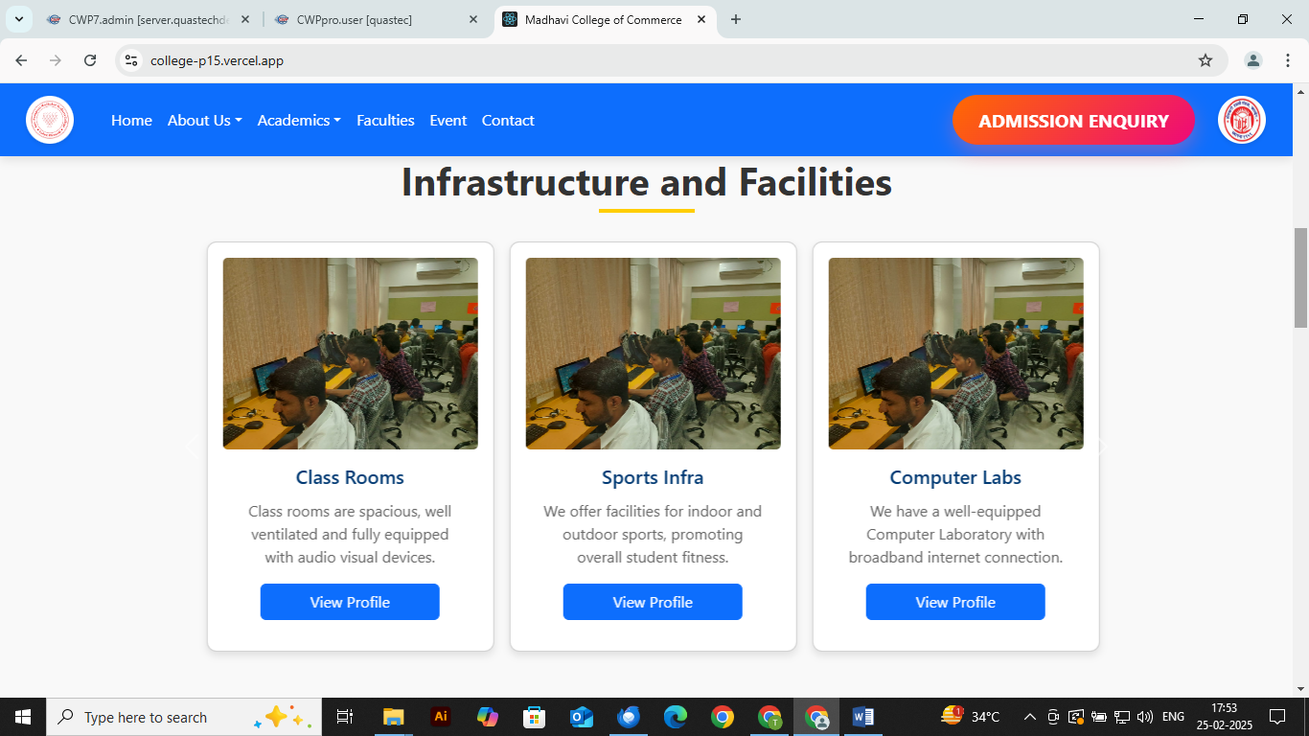

Classroom

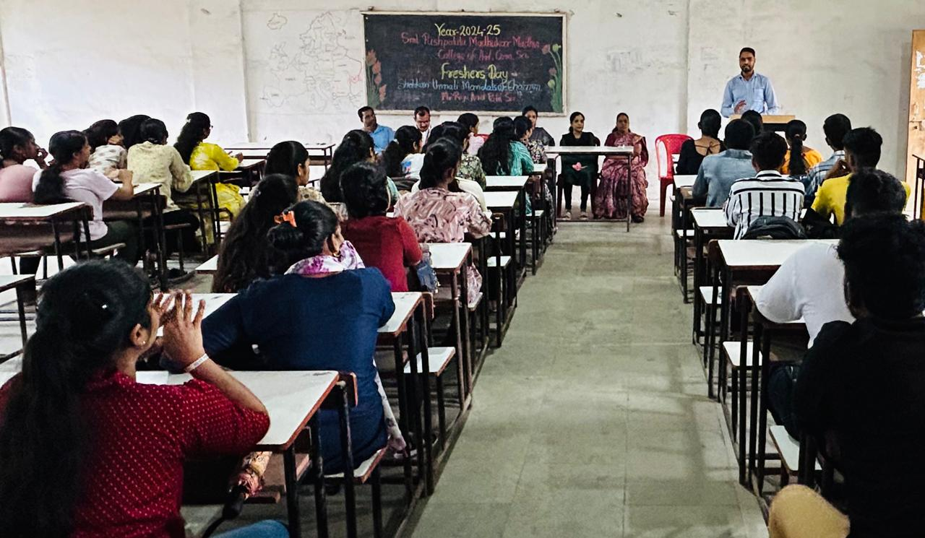

Computer lab

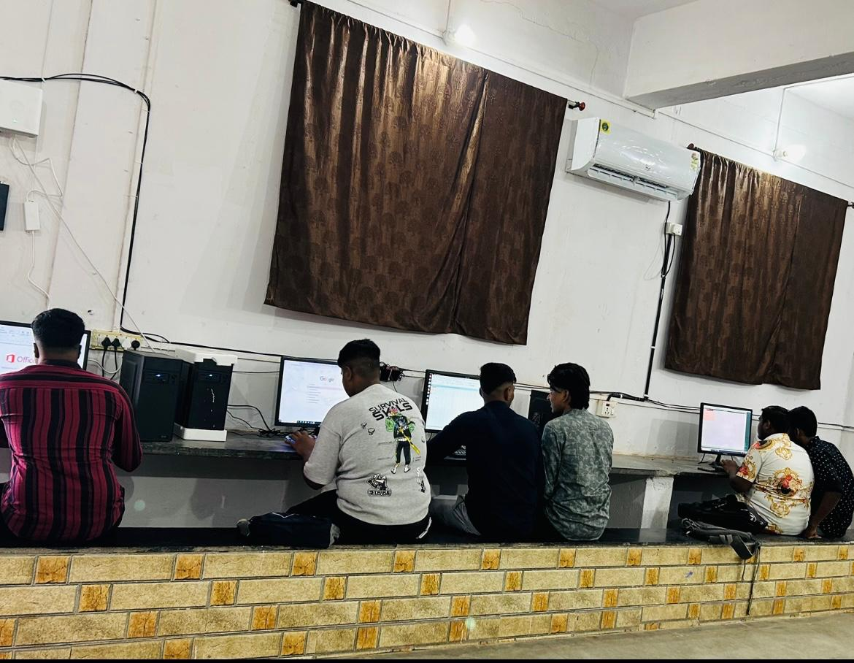

Industrial Visit

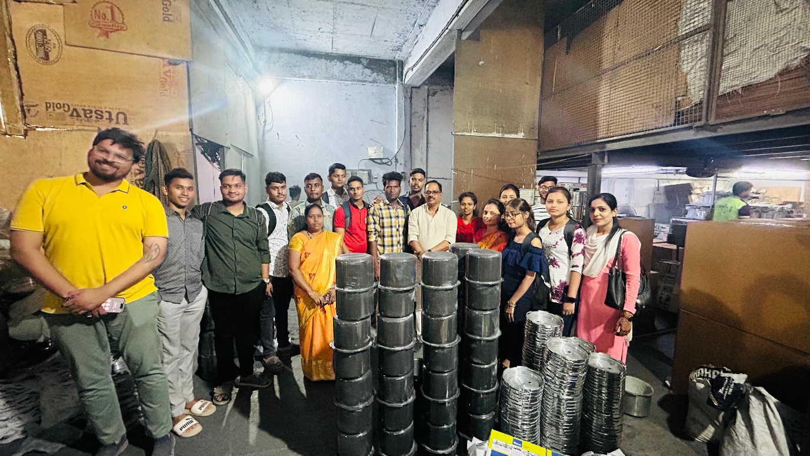

Nss Activities

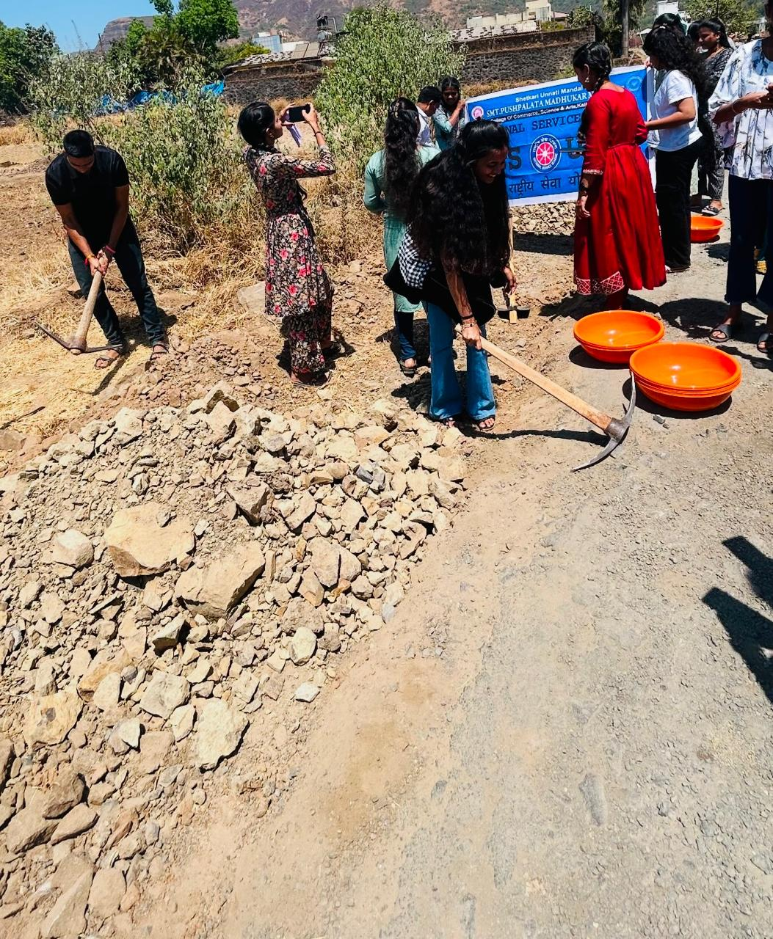

Sports infra

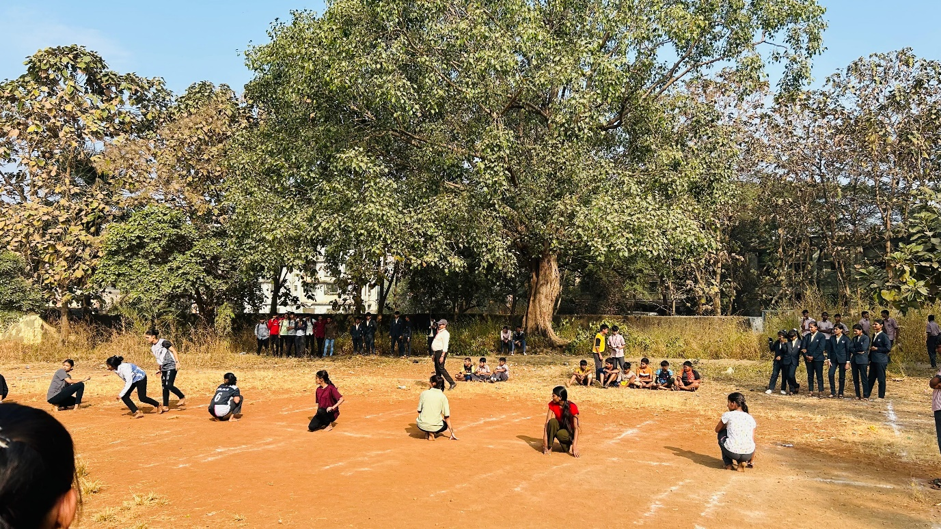

**2) Changes this Design**

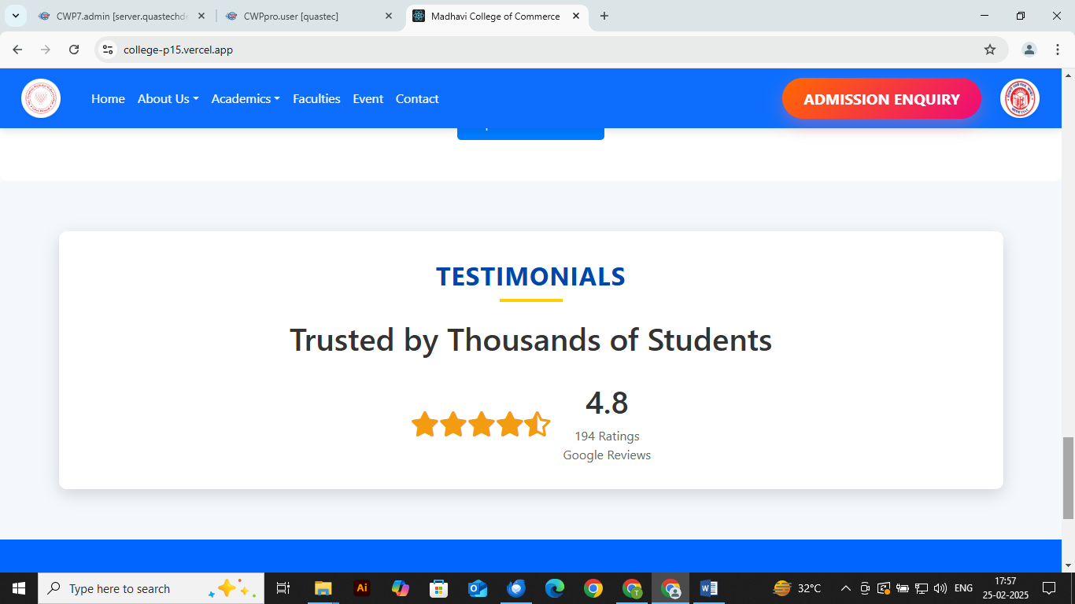

**About Us** **Page**

**Chairman Page**

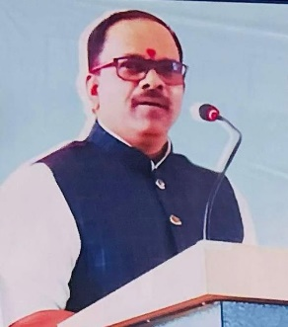

**From the Desk of Chairman**

President – Shri Raju Anant Patil, It gives us a grate pleasure in extending a warm welcome to all our students fraternity, parents & our entire management.

We believe that team work is better than individual work , Our institution team blended with pre-primary, primary, secondary, higher secondary, degree college has grown.

1. Parsharam Dhondu Tawre Vidyalaya, Kalher

2. Premabai sukrysa patil vidyalaya, kariwli, bhiwandi

3. Sitaram rama patil vidyalaya, Amne, bhiwandi

4. Madhavra Patil balmandir, kalher, bhiwandi

5. Abhinav bal vidyamandir english medium school, tadali bhiwandi

6. Anant laxman patil ( Master ) Junior college, kalher bhiwandi

7. Smt. Pushpalata madhukar madhavi college of commerce, science & arts, kalher, bhiwandi

8. Smt. Chandrabai anant patil english medium high school & junior college, kalher

As per our vision we celebrate infinite event like Azadi ka amrut mohotsav, Navratri utsav, khel mohotsav, industrial visit, traditional days celebration, NSS, seminars session as well as inter college fests like push parang anant tarang mohostsav

**-----------------------------------------**

**Principal Page**

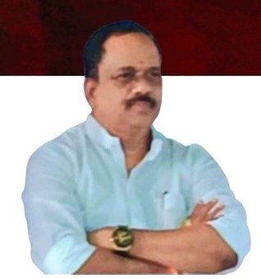

**From The Desk of Principal**

Education is the most important tool for economical change. Shetkari Unnati Mandal’s Shrimati Pushpalata madhukar Madhavi College of Commerce, Science & Arts, Kalher has started with vision to provide education to first learners of the rural society & to promote all round development by organizing & making students participate in curricular, co-curricular & extra curricular activites by developing self confidence of the students. To inculcate respect for human values among students is one of the goals of this institution.

The synergy of my proactive team speaks of high skill, quality & evergreen experiences. SPMM College of commerce, science & arts, kalher ( Senior College ) has a holistic approach which makes our students physically, mentally, socially, spiritually & environmentally prepared to face the global challenges.

We know, for a complete development of students, parents active participation is needed. So, we always remain in consent touch with parents informing the about their word’s performance.

**--------------------**

**Teaching Faculty**

|  |  |  |  |
| --- | --- | --- | --- |
| **Sr.No.** | **Male** | **Sr.No.** | **Female** |
| **1** | **Mr. Tushar Mohan Madhavi** | **1** | **Ms. Divya Chandrakant Bhoir** |
| **2** | **Mr. Tushar Mohan Madhavi** | **2** | **Mrs.Ujwala Bharat Jadhav** |
| **3** | **Mr.Kunal Baliram Bhokre** | **3** | **Mrs. Pratibha Pradip Bhosle** |
| **4** | **Mr.Jaynath Dunda Patil** | **4** | **Mrs.Vaishali Jaidip Patil** |
|  |  |  |  |
|  |  |  |  |
|  |  |  |  |